SM4-NO2-20
https://www.semeatech.com/Products/4_Series_Gas_Sensors/4NO2_Sensors/4NO2-20.html

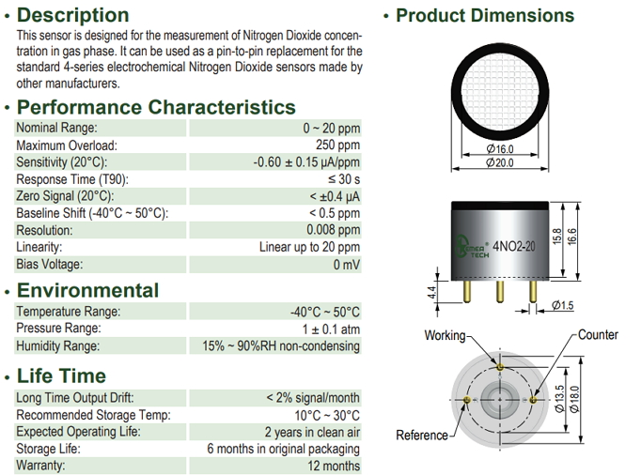

DHT22
https://cdn.sparkfun.com/assets/f/7/d/9/c/DHT22.pdf

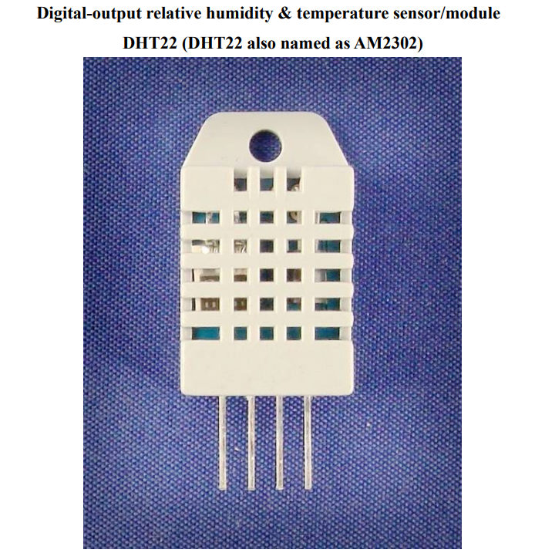

MQ-131 High

https://www.winsen-sensor.com/product/mq131-h.html

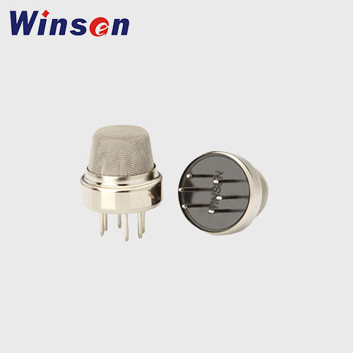

MQ-131 Low
https://cdn.sparkfun.com/assets/9/9/6/e/4/mq131-datasheet-low.pdf

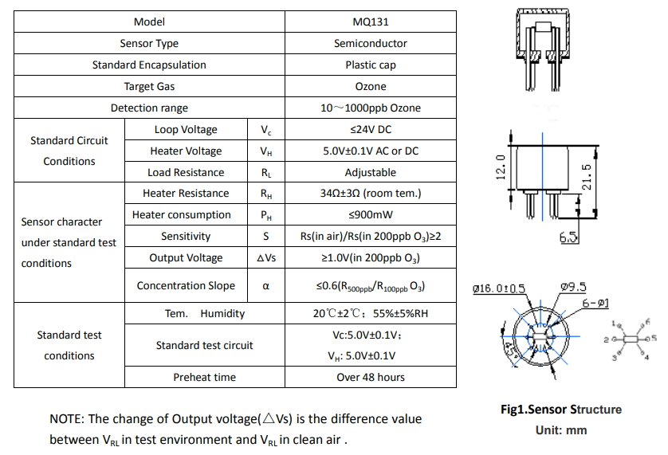

MQ-137
https://www.winsen-sensor.com/d/files/semiconductor/mq137.pdf
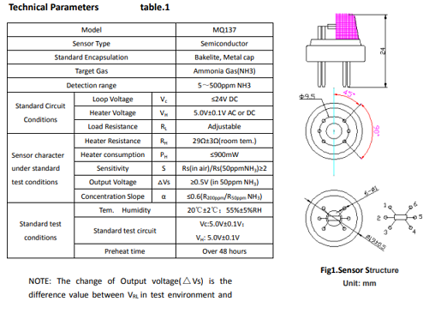

ZE08-CH2O : Use the Module Board

MQ-2
https://www.winsen-sensor.com/d/files/PDF/Semiconductor%20Gas%20Sensor/MQ-2%20(Ver1.4)%20-%20Manual.pdf
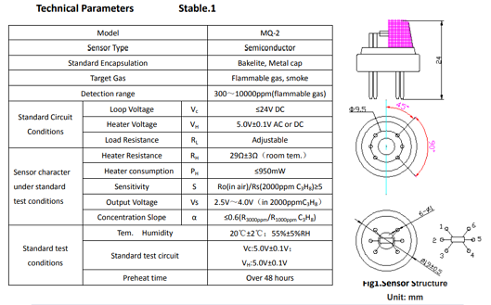

CJMCU-811 : Will use the Module

ZP07 : Will use the Module

MQ-136 : https://www.winsen-sensor.com/d/files/manual/mq136.pdf

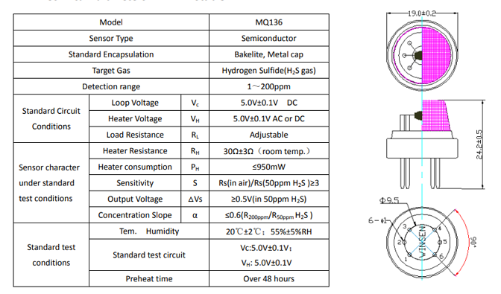

ZE-03 : https://www.winsen-sensor.com/d/files/ze03-electrochemical-module-manualv2_8(6).pdf?campaignid=10468521249&adgroupid=137663190927&feeditemid=&targetid=kwd-1642802074031&device=c&creative=585422844933&keyword=ze03%20sensor&gad_source=1&gad_campaignid=10468521249&gbraid=0AAAAACTVC9T7bmz7hHOx57ZW8gIUIc_kz&gclid=Cj0KCQiAgvPKBhCxARIsAOlK_EpUFF2DUpd7ManF3biNO8n-U3lUhdra11Ej8ai8idoFUG8jdvXOZTsaAj1bEALw_wcB

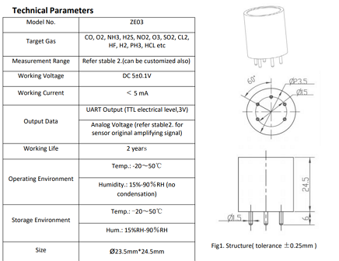

MQ-135 : https://www.winsen-sensor.com/d/files/PDF/Semiconductor%20Gas%20Sensor/MQ135%20(Ver1.4)%20-%20Manual.pdf

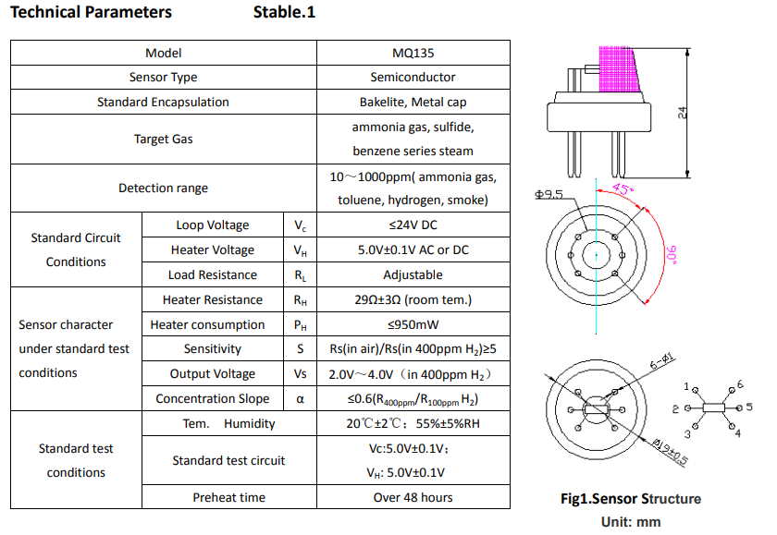

MQ-4 : https://www.winsen-sensor.com/d/files/mq-4-(ver1_6)---manual.pdf

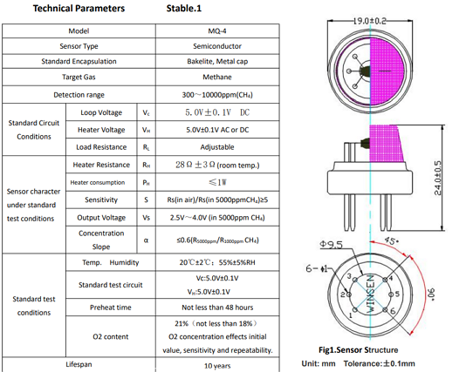

MQ-6 : Raw Sensor
MQ-7 : Raw Sensor
MQ-8 : Raw Sensor

